Highgate Medical Centre
January 2024

Welcome to our first Practice Newsletter which will be published every month, providing an update from the practice and any important information
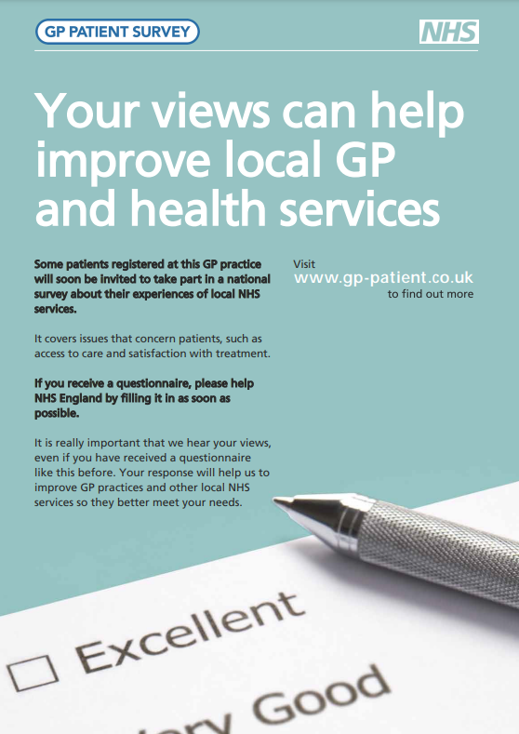
NHS APP
The NHS App allows you to access a range of NHS Services. You can download the NHS App on your smartphone or tablet. Please visit the link below
https://www.nhs.uk/nhs-app/

Patient Participation Group (PPG)
We have an active Patient Participation Group called Friends of Highgate Surgery. The aims of this group are to provide feedback to the practice about its service and act as a support and resource for patients. If you are interested in joining the group, please complete an application form via the surgery website.
https://www.highgatemedicalcentre.co.uk/ppg.aspx?t=1

New cloud-based telephone system

We start the new year with our new cloud-based telephone system. This now includes both a queuing system and a ‘ring back’ service.
So far, we have received excellent feedback regarding this. We would be grateful for your feedback, please let us know what you think when you contact us.

Friends and Family Test Feedback (FFT)
Each week we send out feedback questionnaires to a random selection of patients. If you receive this questionnaire, we would be very grateful for your response so we can understand what we are doing well and where we can improve. A selection of last month’s feedback can be found below:
- Always able to help very professional and friendly

- Always a great experience contacting the surgery

- My needs are always met in a timely manner I
would recommend Highgate without hesitation

- Friendly, compassionate. Knowledgeable in various fields

Dry January supports people across the country to change their relationship with alcohol through stopping drinking for one month using Alcohol Change UK's tools and resources. You can use Dry January to help your community to become healthier and happier. Please visit the link below for more information https://alcoholchange.org.uk/

